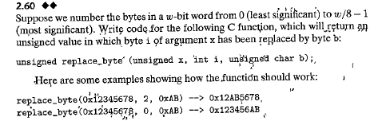

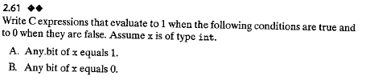

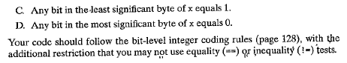

Note：Page 154 for the second edition

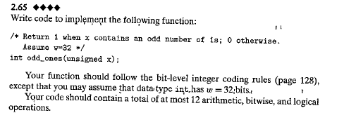

Note：Page 154 for the second edition